PROMPT - PLAN - PRODUCE
Sub-topic: AI Workflow Basics | One-Month Course for Class 12
CHAPTER
Verify Before
You Trust
Sub-topic
The Human Behind AI Decisions
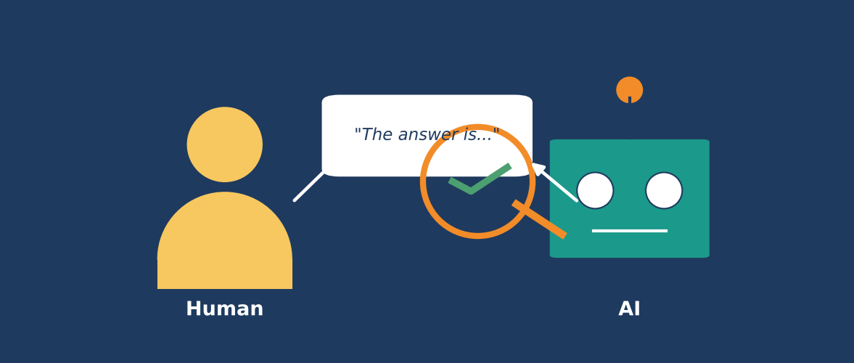
Learn how people shape AI, why AI can be wrong, and how to check before you believe.
Student name: ______________________________
Class / Section: ____________________________

Contents
Section | Title | Page
 | About This Chapter | 3
1 | A Story: The Confident Answer | 5
2 | What Does "Verify Before You Trust" Mean? | 7
3 | How AI Makes Decisions: The Simple Version | 10
4 | The Human Behind AI Decisions | 13
5 | Human Choices That Shape AI | 17
6 | Bias: How AI Can Become Unfair | 20
7 | When AI Gets It Wrong | 23
8 | Two Kinds of Mistakes: False Alarms and Missed Cases | 27
9 | The V-E-R-I-F-Y Method | 29
10 | Sources, Lateral Reading and Fact-Checking | 34
11 | How Much Should You Verify? | 38
12 | Responsibility, Ethics and You | 41
13 | Verify in Prompt - Plan - Produce | 44
14 | Case Studies and Activities | 47
15 | Summary, Glossary and Assessment | 52

KEY IDEA: Pictures in this chapter
- Fig 2.1 The trust spectrum
- Fig 4.1 The people behind one AI decision; Fig 4.2 Humans at every stage
- Fig 6.1 The bias loop
- Fig 7.1 Sounding right is not being right; Fig 7.2 Where AI needs extra checking
- Fig 8.1 Two kinds of AI mistakes
- Fig 9.1 The V-E-R-I-F-Y method
- Fig 10.1 Source reliability ladder; Fig 10.2 Vertical and lateral reading
- Fig 11.1 The stakes matrix; Fig 11.2 Human in, on and out of the loop
- Fig 12.1 A chain of responsibility
- Fig 13.1 Where verification fits in Prompt - Plan - Produce

SECTION 0

About This Chapter

Why this chapter matters
Today, artificial intelligence (AI) is part of daily life. It suggests videos, answers homework questions, writes emails, checks photos, recommends loans, and helps doctors read scans. Many students already use AI tools to study. These tools are fast, polite and confident. But fast does not mean correct, and confident does not mean true.
This chapter teaches one of the most important skills of the AI age: Verify Before You Trust. It means checking an AI answer, an AI decision or an AI-made file before you accept it, share it or act on it. The chapter also teaches a second big idea: behind every AI decision there are human beings who collected the data, made the rules, set the goals and decided where the AI would be used. When you understand the humans behind AI, you understand why AI can be helpful, why it can be wrong, and who is responsible when it is wrong.
This chapter is part of the course Prompt - Plan - Produce (sub-topic: AI Workflow Basics). In that workflow you first Prompt (ask clearly), then Plan (organise the steps) and then Produce (create the result). This chapter adds the safety step that protects every piece of work you produce: Verify.

What you will learn
- Explain in simple words what it means to verify before you trust.
- Describe how an AI system makes a decision, using the ideas of data, patterns and predictions.
- Name the people who are behind AI decisions and explain what each group does.
- Show how human choices about data, goals and rules shape what an AI says and does.
- Explain bias, hallucination, outdated information and overconfidence with examples.
- Use the V-E-R-I-F-Y method to check an AI answer step by step.
- Compare sources using lateral reading and a source reliability ladder.
- Decide how much checking is needed using the stakes matrix.
- Describe who is responsible when AI makes a mistake and what your own responsibility is.
- Add a verification step to your own Prompt - Plan - Produce workflow.

How to use this chapter
- Read each section slowly. Look at every picture. The pictures are part of the lesson.
- Try the Try This boxes. They take only a few minutes and make the ideas stick.
- Discuss the Think About It boxes with friends or your teacher. There is often no single correct answer.
- Use the worksheets at the end to practise the V-E-R-I-F-Y method on real AI answers.
- Keep a Verification Log (a template is given in Section 14) for one month.
REMEMBER: Colour guide for the boxes
- Key Idea (green): the most important point of a topic.
- Think About It (orange): a question for discussion.
- Try This (purple): a small activity.
- Be Careful (red): a common mistake or danger.
- Story / Example (blue / light green): a situation that shows the idea in real life.

Chapter map
Section | Topic | Main question
1 | A story: The Confident Answer | What can go wrong when we trust too fast?
2 | What does Verify Before You Trust mean? | What is trust, and how much is enough?
3 | How AI makes decisions | Where do AI answers come from?
4 | The Human Behind AI Decisions | Who builds, runs and controls AI?
5 | Human choices that shape AI | How do people's decisions change AI results?
6 | Bias: unfairness in AI | How can AI become unfair?
7 | When AI gets it wrong | What kinds of mistakes does AI make?
8 | Two kinds of mistakes | Which mistake costs more?
9 | The V-E-R-I-F-Y method | How do I check an AI answer?
10 | Sources, lateral reading and fact-checking | Which sources can I rely on?
11 | How much should you verify? | How do I match checking to risk?
12 | Responsibility and ethics | Who is responsible when AI fails?
13 | Verify in Prompt - Plan - Produce | How do I build checking into my workflow?
14 | Case studies and activities | How do I practise?
15 | Summary, glossary and assessment | What did I learn?

SECTION 1

A Story: The Confident Answer
Before we study ideas, let us begin with a story. The story is fictional, but situations like this happen to students, workers and even professionals every day.
STORY: Meera's project
Meera is a Class 12 student in Coimbatore. Her economics teacher has asked every student to prepare a one-page note on "Causes of inflation in India" and to include three facts with numbers. The note is due the next morning. It is already 9 p.m.
Meera opens an AI chat tool and types: "Give me five facts with numbers about inflation in India." Within seconds, the tool gives five neat points. Each has a percentage, a year and the name of an organisation. The English is smooth and professional. Meera is relieved. She copies the points into her note, adds a heading and goes to sleep.
The next day, her teacher reads the note and circles two numbers. "Where did you get this figure?" she asks. Meera says, "From an AI tool." The teacher smiles gently and says, "Please check it against the official statistics." That evening Meera checks. One number is close but from a different year. Another number does not match any official report she can find. One organisation named in the answer does not publish that kind of data at all.

What went wrong?
Let us think about Meera's story step by step. It is important to notice that nobody lied on purpose. The AI tool was not trying to cheat Meera. Meera was not lazy. She was under time pressure. Yet the final note contained mistakes. Why?
- The answer looked professional. Smooth language, numbers and organisation names made the answer feel official. Our brains often treat neat presentation as proof of truth.
- Meera did not ask for sources. She did not ask where the numbers came from, so she had nothing to check.
- Meera did not check anything. She trusted the first answer completely.
- The stakes felt low. It was only a school note. But habits formed in small tasks follow us into bigger decisions.
- She forgot there are humans behind the tool. People built the tool, chose its training data and set its rules. The tool does not "know" India's economy the way an economist does. It predicts text that looks right.
THINK ABOUT IT: Discuss
Have you ever copied something from an AI tool or website without checking it? What happened?
If Meera had submitted the note without the teacher noticing, who would have been responsible for the wrong numbers: the AI tool, the company that made it, or Meera? Give reasons.

The same story, told the better way
Now imagine Meera had followed the habit you will learn in this chapter. Her evening might have looked like this:
Step | What Meera did | Time taken
1 | Asked the AI tool: "Give me five facts about inflation in India and tell me the source of each. If you are not sure, say so." | 1 minute
2 | Read the answer and underlined every number, year and organisation name. | 2 minutes
3 | Opened the official website of the relevant government statistics office and searched for the same figures. | 8 minutes
4 | Found that two numbers matched, one was from a different year, and one could not be found. She kept the two matching facts and corrected the third using the official number. | 5 minutes
5 | Wrote a small line in her note: "Source: official statistics release, checked on 12 October." | 1 minute

Total extra time: about 17 minutes. The result: a correct note, a happy teacher and a student who learned how to use AI safely. Seventeen minutes of checking protected hours of embarrassment. That is the whole message of this chapter in one sentence.
KEY IDEA
AI can help you start quickly. Only verification helps you finish correctly. A good AI user is not the person who gets answers fastest, but the person who knows which answers to trust.

SECTION 2

What Does "Verify Before You Trust" Mean?

2.1 Understanding the word trust
Trust means believing that something or someone will behave the way we expect. We trust a bus driver to drive carefully. We trust a pharmacist to give the right medicine. We trust a calculator to add numbers correctly. In each case, our trust is based on reasons: training, rules, past experience or proof.
Trust becomes dangerous when it is automatic (given without reasons) or too large (bigger than the evidence supports). Think about it: you trust a calculator for 12 x 15 because calculators are built to be exact. You should not trust a stranger on social media about a medicine, because you have no reasons to do so. Where does an AI tool fit? Somewhere in between, and the exact place changes with the question you ask.

2.2 Understanding the word verify
To verify means to check whether something is true, correct or reliable by using evidence. Verification is not insulting. Doctors verify a diagnosis with tests. Banks verify identity before giving money. Pilots run a checklist before every flight, even though they have flown thousands of times. Verification is what careful people do because the result matters.
KEY IDEA: Verify Before You Trust
Verify Before You Trust means: do not accept an AI answer, decision or file just because it sounds right or comes from a smart-looking tool. First check it with evidence. Then decide how far to trust it.

2.3 The trust spectrum
People often think there are only two choices: believe everything or believe nothing. Real life is more interesting. Look at Figure 2.1.
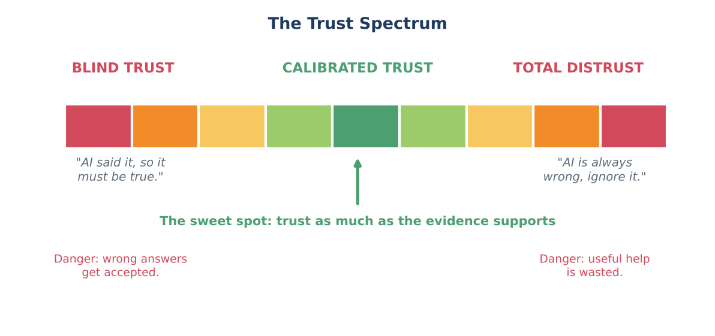
Figure 2.1: Trust is a spectrum. The goal is calibrated trust in the middle.
On the left side is blind trust: "The AI said it, so it must be true." This is risky because AI systems make mistakes, and blind trust means nobody catches them. On the right side is total distrust: "AI is always wrong, so I will never use it." This is also a mistake, because AI can save time, explain difficult ideas, and help you find errors in your own work.
In the middle is calibrated trust. The word calibrated comes from measuring instruments. A calibrated weighing scale shows the correct weight because it has been checked against a standard. In the same way, calibrated trust means your trust is adjusted to match the evidence. You trust more when evidence is strong, less when evidence is weak, and you check when you are unsure.

2.4 Why do we trust too quickly?
Psychologists have found several habits of the mind that make us trust AI too fast. Knowing them is the first step to protecting ourselves.
Habit of mind | What it means | Example with AI
Fluency effect | Smooth, clear language feels more true. | A well-written paragraph feels correct even if one fact is wrong.
Authority bias | We believe things from important-looking sources. | "This is a powerful AI, so it must know."
Automation bias | We trust a machine's output over our own judgment. | Accepting a calculator-style answer even when it looks odd.
Confirmation bias | We accept answers that match what we already believe. | Using the AI answer that supports our opinion and ignoring the other.
Laziness and hurry | Checking takes effort, so we skip it. | Copying an answer at midnight before a deadline.
Social proof | If many people use it, we think it must be right. | "Everyone in class uses this tool, so it must be fine."

TRY THIS: Spot your own habit
Look at the table above. Which habit do you think affects you most? Write one real situation from your life where it happened. Share it with a partner.

2.5 Verification is a skill, not a sign of weakness
Some students feel that checking an answer means they are "not smart enough" to understand it, or that using AI means they should not need to check. This is the opposite of the truth. Skilled people verify more, not less. A senior doctor checks lab results twice. A good journalist confirms a fact with a second source. A good engineer runs tests even on code that looks perfect. Verification is the habit that separates professionals from beginners.
In the future workplace, many jobs will involve working with AI tools. Employers will not only ask, "Can you use AI?" They will also ask, "Can you tell when the AI is wrong?" This chapter prepares you for the second question.
BE CAREFUL
Verification does not mean you must check every word of every AI output for hours. It means you check smartly: more for important facts, numbers, names, dates, advice and decisions; less for low-risk things such as a casual brainstorming idea. You will learn how in Sections 9 and 11.

SECTION 3

How AI Makes Decisions: The Simple Version
To verify AI well, you need a basic picture of what AI is doing inside. You do not need advanced mathematics. A simple story is enough.

3.1 Learning from examples
Imagine a student named Arjun who wants to learn how to recognise mango varieties. His uncle, who owns a fruit shop, shows him 1,000 mangoes. For each mango the uncle says the name: Alphonso, Banganapalli, Totapuri and so on. After seeing many examples, Arjun starts to notice patterns: shape, colour, size, smell. Soon, when he sees a new mango, he can guess its name.
Many AI systems learn in a similar way. They are shown huge numbers of examples (the training data). They find patterns in that data. Later, when they see something new, they use the patterns to make a prediction or a decision. This type of AI is often called machine learning.
KEY IDEA: Three words to remember
- Data: the examples the AI learns from (text, pictures, numbers, sounds).
- Pattern: a repeating relationship the AI finds in the data.
- Prediction: the AI's best guess about a new case, based on the patterns.

3.2 How chatbots like AI writing tools work
AI writing assistants are built on large language models. A large language model is trained on a massive amount of text. During training, it learns which words usually follow which other words in which situations. When you ask a question, it builds an answer one small piece at a time, each time choosing a likely next piece based on patterns it learned.
This explains why the answers sound natural. But it also explains a danger: the model is designed to produce likely-sounding text, not to look up a guaranteed fact. If it has seen strong patterns for a topic, the answer is usually good. If the topic is rare, new, or has little data, the model may produce something that sounds right but is wrong. Researchers call this hallucination. You will study it in Section 7.
EXAMPLE: A student who only read cricket books
Suppose a student has read hundreds of cricket books but no chemistry books. If you ask about the highest score in a Test innings, they answer well. If you ask about chemical bonds, they might still answer in a confident voice, using cricket-style language, and be wrong. AI is similar: it is strong where its training data was strong, and weak where data was thin, old or unbalanced.

3.3 Other kinds of AI decisions
Not all AI writes text. AI also makes decisions in many other areas. Here are common examples that you may meet in the next few years.
Area | What the AI decides | Data it uses
Banking | Whether a transaction looks like fraud; whether to approve a small loan. | Past transactions, income records, repayment history.
Hiring | Which job applications to show first. | Resumes, past hiring outcomes, keywords.
Healthcare | Whether a scan shows a possible problem. | Thousands of labelled medical images.
Education | Which lesson or question to show next to a learner. | Student answers, time taken, topics missed.
Social media | Which posts and videos to show you. | What you watched, liked, shared and skipped.
Transport | Best route or traffic signal timing. | Live traffic, map data, past patterns.
Online shopping | Which products to recommend; price offers. | Browsing history, purchases, similar customers.

3.4 What AI does not do
It helps to be clear about what AI does not do, even when it feels as if it does:
- AI does not understand the world like a human. It finds patterns in data. It does not have real-life experience, feelings or common sense in the human way.
- AI does not automatically know what is true. It knows what its data and training pushed it to produce. If the data had mistakes, the AI can repeat them.
- AI does not know what happened after its training ended, unless it is connected to a live source of information. Its knowledge can be out of date.
- AI does not take responsibility. It cannot be blamed, punished or held to account. Humans and organisations carry the responsibility.
THINK ABOUT IT: Pause and discuss
If an AI is only predicting likely answers, why might a very confident tone be misleading? What would a more honest AI answer sound like?

3.5 From prediction to decision
A prediction becomes a decision when someone or something acts on it. For example, a bank's AI predicts that a transaction has a 92% chance of being fraud. That is a prediction. A rule then says, "If the chance is above 85%, block the transaction." That is a decision. Notice something very important: the number 85% was chosen by a human. If a human had chosen 95%, fewer honest customers would be blocked, but more fraud would pass. If a human had chosen 70%, more fraud would be caught, but many honest customers would be blocked. The AI did the calculation. A human decided what to do with it.
This simple example leads us to the heart of this chapter: behind AI decisions there are human choices. The next section explores them.

SECTION 4

The Human Behind AI Decisions
When people say, "The AI decided," they hide a long chain of human work. It is like saying, "The building stood tall," and forgetting the architects, engineers, workers and inspectors who made it. In this section we open the curtain and meet the humans behind AI decisions.

4.1 The people around an AI decision
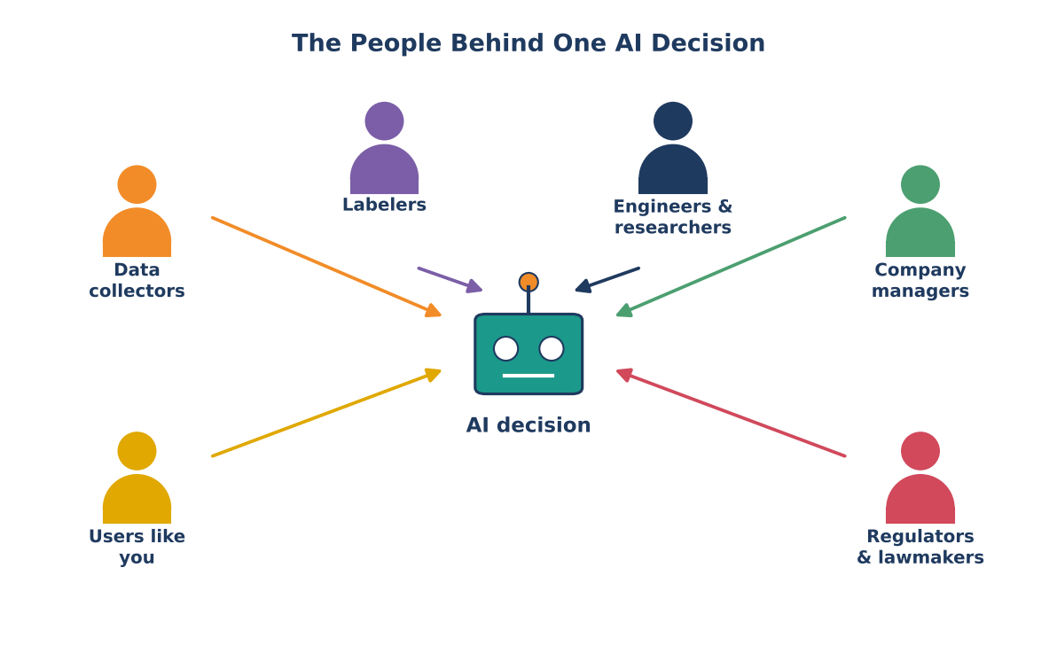
Figure 4.1: Many different people influence one AI decision.
Look at Figure 4.1. Every AI decision is touched by several groups of people. Let us meet each group.

Data collectors
They gather the information the AI learns from: photos, text, sound recordings, forms, sensor readings. They decide where to collect the data, from whom, and how much. If they collect only from big cities, the AI may work poorly for villages. If they collect only old data, the AI may be out of touch with today.

Labelers and annotators
Many AI systems need humans to tag examples: "This photo shows a cat", "This review is positive", "This message is spam". Labelers do this work, often thousands of times a day. Their understanding, tiredness, culture and instructions affect the labels. If two labelers disagree, the AI learns a mixed signal.

Engineers and researchers
They design the model, choose how it learns, decide what counts as "good performance", test it and fix problems. Their choices about goals, tests and settings shape every answer the AI gives.

Company managers and product teams
They decide why the AI is being built, who it is for, how it will make money, how fast it must be released and what risks are acceptable. A team under pressure to launch quickly may test less. A team that values safety may add more checks.

Regulators and lawmakers
They make rules about privacy, fairness, safety and honesty. Governments, courts and industry bodies decide what AI systems may or may not do, and what happens if they break the rules.

Users like you
You are also part of the chain. You choose the tool, write the prompt, decide whether to check the answer, and decide what to do with it. Your actions, such as sharing a wrong answer, can spread a mistake further.
KEY IDEA
AI is not a separate, mysterious being making decisions on its own. It is a tool built, trained, configured and used by people. Understanding the people means understanding why the tool behaves as it does, and where to check it.

4.2 Humans at every stage of an AI system
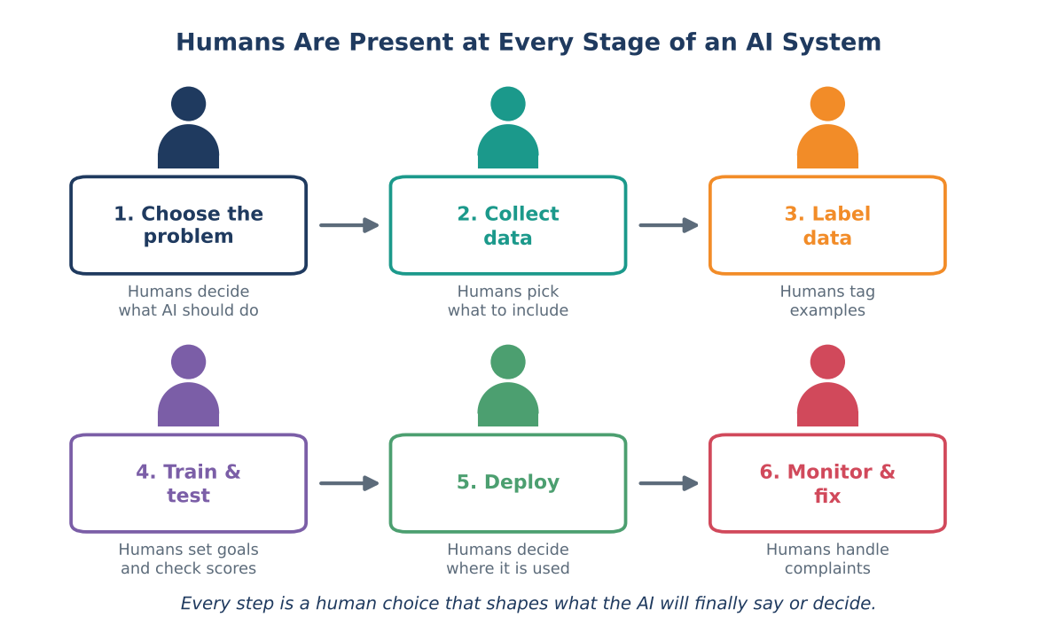
Figure 4.2: Human choices appear in every stage of building and using AI.
Figure 4.2 shows six stages in the life of an AI system. At each stage, human choices are made. Let us study each stage with an example. We will use a simple running example: a school wants an AI tool to flag students who may need extra study support.

Stage 1: Choose the problem
Humans decide what problem the AI should solve. In our example, the school decides: "We want to find students who may need help early." Already there is a choice. The school could have chosen another goal, such as "find students who may drop out" or "find students who need counselling." Each goal leads to a different system, different data and different consequences. Questions to ask: Who asked for this AI? What problem is it supposed to solve? Is AI the right tool at all?

Stage 2: Collect data
Humans decide what information to give the AI. The school could use marks, attendance, homework submission and class participation. It might also be tempted to use data such as home address, family income or the student's gender. Each choice has consequences. Using home address might unfairly mark students from certain neighbourhoods. Humans must decide what is relevant, fair and allowed. Questions to ask: What data was used? Who is missing from it? Is it recent? Was it collected fairly and with permission?

Stage 3: Label the data
In our example, someone must decide which past students "needed support" so that the AI can learn from them. Was it students who failed an exam? Students whom teachers recorded as struggling? Students who joined remedial classes? Different definitions produce different AIs. Questions to ask: Who labelled the data? Based on what rules? Did labelers agree with each other?

Stage 4: Train and test
Engineers train the model and test how well it works. They decide what "works well" means: Should the AI catch as many struggling students as possible, even if it wrongly flags some who are fine? Or should it only flag when it is very sure, even if it misses some students? They also decide which students to test on. If they test only on top-ranking classes, they may not see problems in other groups. Questions to ask: How was it tested? On whom? What mistakes does it still make?

Stage 5: Deploy
Humans decide where and how the AI will be used. Will teachers see its results as a hint or as a final decision? Will parents be told? Can students ask for a review? The same AI used as "a gentle suggestion for the teacher" is very different from the same AI used as "an automatic decision to move students to another section." Questions to ask: Who sees the AI's output? Can a human override it? Is there a way to complain?

Stage 6: Monitor and fix
After release, humans must watch how the AI performs in real life, listen to complaints, find errors, update the data and improve the system. The world changes: new syllabus, new exam pattern, new student needs. An AI that is never updated slowly becomes less accurate. Questions to ask: Who is responsible for checking it regularly? What happens when it fails?
TRY THIS: Draw your own pipeline
Choose one AI tool you use (a video recommendation feed, a navigation app, a chatbot). On paper, draw six boxes like Figure 4.2. For each stage, write one human decision that must have been made. Then write one question you would like to ask the builders.

4.3 "The algorithm decided" is not a full explanation
You may have heard people say, "Sorry, the system rejected it" or "The algorithm decided." This phrase can be a way to avoid responsibility. In reality, humans chose to use the algorithm, chose what data to give it and chose to accept its outputs. When something goes wrong, the correct question is not only "What did the AI do?" but also "Which human decisions led to this result, and who can fix them?"
EXAMPLE: A school canteen example
A school installs an AI system to predict how many meals to prepare each day. One week, the system under-predicts and many students go hungry. The canteen manager says, "The AI got it wrong." But the real questions are: Who chose the data? Did anyone tell the AI about a school event that increased attendance? Did anyone check the predictions before cooking? Was there a backup plan? Seen this way, the AI error is also a human planning error.

SECTION 5

Human Choices That Shape AI
In Section 4 we met the people behind AI. Now we look closely at the choices they make. Each choice may seem small, but together they decide how the AI behaves. If you know the common choices, you know where to look when you verify an AI result.

5.1 Seven big human choices
Human choice | Simple example | How it changes the AI result
1. The goal | A video app aims for "maximum watch time" instead of "most useful videos". | The AI learns to keep you watching, not to keep you well informed.
2. The data | A speech tool is trained mostly on clear studio recordings. | It struggles with noisy classrooms, regional accents or older voices.
3. The labels | People tag messages as "rude" using their own cultural idea of rudeness. | The AI may flag harmless messages from some communities.
4. The settings (thresholds) | A fraud system blocks payments above a 70% risk score. | Lower setting: more honest users blocked. Higher setting: more fraud missed.
5. The rules and limits | A chatbot is told not to give medical advice. | It refuses some questions, even helpful safe ones, or answers carefully.
6. The testing | A face app is tested mainly on young adults. | Hidden errors for children and older people go unnoticed.
7. The way it is used | A teacher uses an essay-score AI as a final grade instead of a hint. | A small AI error becomes a big unfair result for a student.

5.2 A closer look at the threshold choice
The threshold example is worth studying slowly, because it shows that the AI calculates, but a human decides what to do with the calculation.
EXAMPLE: Fraud alert thresholds (numbers are illustrative)
A bank's AI scores 1,000 payments in a day. In reality, 20 of them are fraud. The AI gives each payment a risk score from 0 to 100. The bank must choose the score above which it will block a payment. Look at three possible choices:

Block if score is above | Frauds caught (out of 20) | Honest payments blocked (out of 980) | What it means
90 | 10 | 5 | Very few honest users annoyed, but half the fraud slips through.
70 | 17 | 60 | Most fraud caught, but 60 honest customers are blocked and must call the bank.
50 | 19 | 200 | Almost all fraud caught, but 200 honest customers are blocked. Customers become angry.

There is no perfect setting. Humans in the bank must weigh costs: money lost to fraud, the time of customers, the cost of the call centre, the trust of customers. Different humans, different values, different settings. When a payment of yours is blocked, it is not because the AI "hates" you. It is because of a number someone chose.

5.3 The prompt is also a human choice
When you use an AI writing tool, you are one of the humans making choices. The words of your prompt shape the answer. Look at this comparison.
Prompt written by the user | Likely result
"Tell me why electric vehicles are bad." | A one-sided list of problems. The question assumed the answer.
"Tell me why electric vehicles are good." | A one-sided list of benefits.
"Compare benefits and drawbacks of electric vehicles for city commuters in India. Give sources and say where experts disagree." | A balanced answer, with details you can check.

A leading question (one that already contains the answer you want) can push the AI to agree with you. This is sometimes called sycophancy: the tendency of an AI to please the user rather than correct the user. A careful user asks neutral questions and sometimes asks the AI to argue against their own view.
TRY THIS: Two prompts, two answers
Pick a topic you care about. Write one leading prompt and one neutral prompt. Compare the answers. Which answer would you trust more, and why? Which parts would you still verify?

5.4 Human values inside the machine
Sometimes people say, "Computers are logical, so they have no opinions." But AI is trained on human writing, human photos and human decisions, and is built by people who make choices about what is acceptable. So human values, opinions and blind spots can be carried inside AI, even when nobody intends it. This is not always bad. For example, we want AI to value safety and honesty. But we must remember that the values were chosen by humans and may not suit every situation or every culture.
KEY IDEA
Every AI result reflects: (1) the goal someone chose, (2) the data someone gathered, (3) the rules someone wrote, (4) the tests someone ran, and (5) the way someone used it. To verify an AI result, ask which of these five could have gone wrong.

SECTION 6

Bias: How AI Can Become Unfair

6.1 What is bias?
In everyday life, bias means leaning unfairly toward or against someone or something. In AI, bias means that a system gives systematically unfair or skewed results for some people or situations. "Systematically" means that it happens again and again in a pattern, not just once by accident.
AI bias is rarely planned. Usually nobody says, "Let us build an unfair machine." Bias sneaks in through the data, the labels, the goals and the way the system is used. This is why verification matters: bias can hide inside answers that look neat and neutral.

6.2 Where does bias come from?
Source of bias | Simple explanation | Example
Old or historical data | The data records past unfairness, and the AI copies it. | A hiring AI learns from past hiring where mostly men were selected.
Missing groups | Some groups are not in the data enough. | A health app tested mostly on city adults works poorly for rural elders.
Human labels | Labelers' opinions enter the labels. | "Professional-looking" photos labelled using narrow ideas of looks.
Proxy data | A harmless-looking data field secretly stands for something sensitive. | Using pin code in loan scoring can indirectly reflect caste, religion or income.
Goal choice | The goal pushes the AI to favour some outcomes. | A news feed that maximises clicks promotes shocking content.
Feedback loops | The AI's results create new data that repeats the same pattern. | More police sent to one area leads to more arrests there, which the AI reads as proof of more crime.

6.3 The bias loop
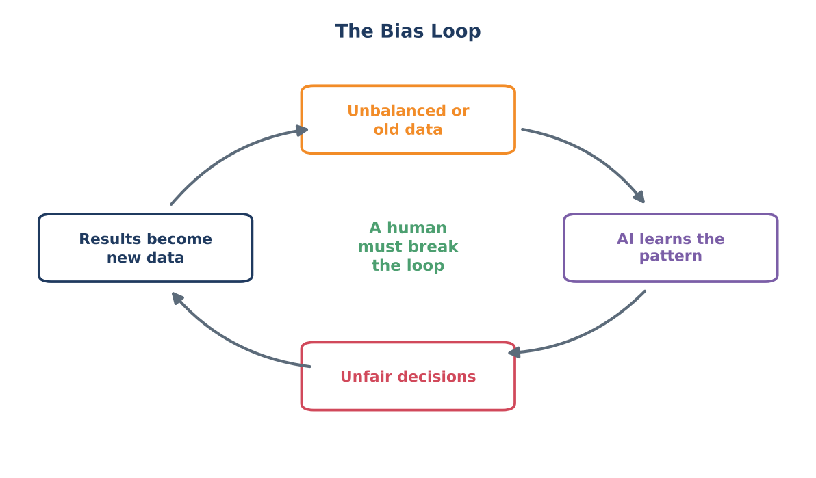
Figure 6.1: Bias can feed itself unless a human breaks the loop.
Figure 6.1 shows why bias can grow. Imagine a company's AI learns from old hiring data (unbalanced data). It learns that people from a certain group were rarely hired (it learns the pattern). It then ranks new candidates from that group lower (unfair decisions). Fewer of them are hired, and the new hiring data is again unbalanced (results become new data). The loop repeats and may become stronger. Only a human who notices the pattern and changes the data, rules or process can break the loop.

6.4 Real cases from the news
The following cases have been widely reported. They are included to show how serious the issue can be. Read them as lessons, not as blame.
EXAMPLE: Case 1: A hiring tool that learned an old habit
In 2018, news agencies reported that a large technology company had tested an experimental AI tool to rank job applicants and then stopped using it. The tool had learned from resumes submitted over about ten years, most of which came from men. Reports said the tool began to rate resumes lower when they included signals linked to women. The lesson: when past data reflects unfair patterns, AI can learn those patterns as if they were good rules.

EXAMPLE: Case 2: Faces that are recognised unequally
In 2018, researchers Joy Buolamwini and Timnit Gebru published a study called "Gender Shades". They tested commercial systems that guess the gender of a face. They found that the error rates were much higher for darker-skinned women (over 30 percent in some systems) than for lighter-skinned men (under 1 percent). The lesson: a system can look "highly accurate" overall while failing badly for particular groups. Always ask: accurate for whom?

EXAMPLE: Case 3: Risk scores in courts
In 2016, a news investigation by ProPublica examined a software tool used in some US courts to estimate the chance that a person would commit another crime. The investigation reported that Black defendants who did not go on to re-offend were more likely to be labelled high-risk than white defendants. The company that made the tool disagreed with the analysis, and experts continued to debate how fairness should be measured. The lesson: fairness itself can be defined in different ways, and humans must decide which definition to use.

EXAMPLE: Case 4: A chatbot that learned from the crowd
In 2016, a technology company released an experimental chatbot on social media that learned from conversations with users. Within about a day, some users taught it offensive language and the company took it offline. The lesson: AI that learns from public input can absorb the worst as well as the best of what it sees, which is why humans must set limits and monitor it.

6.5 What can humans do about bias?
- Use broader, balanced data that includes different regions, languages, ages, genders and backgrounds.
- Test on different groups separately, not only on the average. Ask: how does it perform for each group?
- Remove or limit sensitive and proxy data where it should not influence the decision.
- Keep a human in the process for important decisions and give people a way to appeal.
- Audit regularly. Check results again after release because the world and the data change.
- Be open. Explain what the system does, what data it uses and what its limits are.
THINK ABOUT IT: Bias detective
Your school uses an AI tool that predicts which students will score high in the board exams, and those students are given extra coaching. Write three ways this tool could be unfair to some students. Then write two questions you would ask the school before trusting its predictions.

BE CAREFUL: Do not confuse bias with opinion
AI bias does not always look like an obvious opinion. Often it looks like missing information, odd absences or unequal quality: a tool that gives rich answers about one language and weak answers about another; a picture generator that always shows the same kind of person for "doctor". Compare outputs for different groups or topics to notice it.

SECTION 7

When AI Gets It Wrong
AI tools are useful partly because they are quick and flexible. But being flexible also means being capable of many kinds of mistakes. Knowing the common kinds helps you spot them. In this section we study the most common types.

7.1 Hallucination: sounding right but being wrong
In AI, a hallucination is an output that is false, made-up or unsupported by evidence, yet is presented as if it were true. A hallucination can be a fake fact, a non-existent book, a wrong date, an invented quotation or a made-up web link.
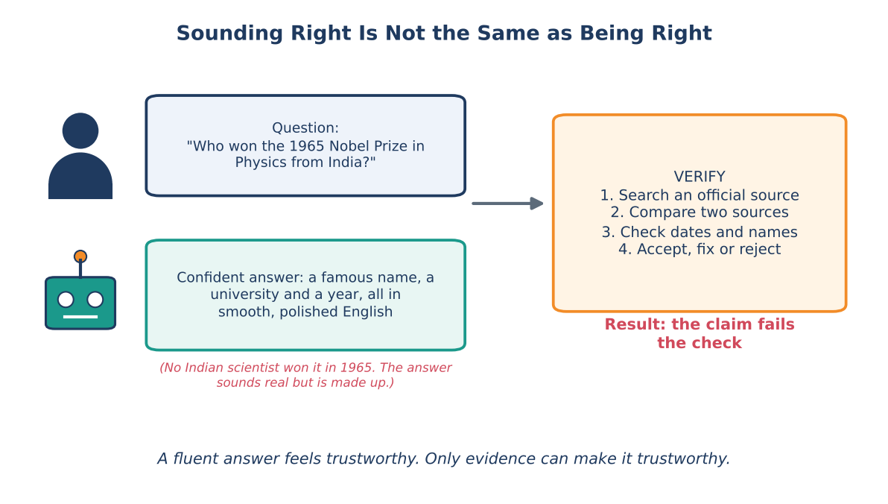
Figure 7.1: A confident answer can be completely made up. Verification catches it.
Why does it happen? Remember from Section 3 that a language model builds answers by choosing likely words. If it does not have a strong pattern for the exact fact, it still tries to produce something that fits. The result may look perfect: correct grammar, correct style, even realistic names. But it is like a convincing actor playing a doctor. The performance is good, but the person is not a doctor.
EXAMPLE: Fake cases in a real court
In 2023, in the United States, lawyers in a case called Mata v. Avianca filed a legal document that contained references to court cases that did not exist. The cases had been produced by an AI chatbot, and the lawyers had not checked them. The judge criticised the lawyers and ordered them to pay a penalty. The lesson: even highly trained professionals can be harmed if they trust an AI answer without checking.

7.2 Outdated information
Many AI tools learn from data up to a certain date, called the training cutoff. After that date, the tool may know nothing unless it is connected to a live search. Questions such as "Who is the current minister?", "What is today's price?", "What is the latest rule for this exam?" can produce old answers presented as current. When the question is about something that changes, check a live, official source.

7.3 Overconfidence
AI tools rarely say, "I am not sure." Their tone is usually steady and polite whether the answer is right or wrong. A human expert may hesitate when unsure. An AI may not. So you cannot use tone as a signal of accuracy. You can sometimes ask the AI to show its uncertainty ("Tell me which parts you are unsure about") but even that is not a guarantee.

7.4 Misunderstanding the question or context
If a question is vague, the AI may choose one meaning and answer it confidently. Example: "What is the best bank?" Best for whom? For students, for farmers, for companies? An AI may also miss local context: Indian board exam patterns, state-level rules or a school's own policy. When context matters, give the context in your prompt and then check the answer against the real rules.

7.5 Calculation and logic slips
AI tools can make arithmetic errors, miss a step in a logical argument or misread a table. This is especially common in long, multi-step problems. For numbers, always recompute with a calculator or a spreadsheet. For logic, test the answer with an easy example.

7.6 Fake or broken sources
When asked for sources, some AI tools may produce book titles, article names or web links that look right but do not exist or do not say what is claimed. Always open the link. Search for the book or paper title in a library catalogue or a trusted database. If you cannot find it, treat it as unverified.

7.7 Synthetic media: fake images, audio and video
AI can also create realistic pictures, voices and videos, sometimes called deepfakes. A fake voice message can sound like a family member. A fake video can show a public figure saying something they never said. Because we naturally believe what we see and hear, such content is powerful and dangerous.
- Check where it came from. Was it posted by a trusted source or forwarded from an unknown account?
- Look for small mistakes: strange hands, text that looks wrong, shadows in the wrong place, lip movements that do not match the voice, unnatural blinking.
- Search for the same event in trusted news. If something shocking really happened, reliable organisations will report it.
- Use reverse image search to see if the picture was taken from somewhere else.
- Pause before sharing. Strong emotion (anger, fear, excitement) is a signal to check first.
BE CAREFUL: Voice and video scams
Criminals can use AI voices to imitate a relative asking for urgent money. If you receive such a call or message, hang up and call the person on their known number. Agree on a family code word. Never send money or share OTPs based only on a voice or video.

7.8 Summary table of common AI errors
Error type | What it looks like | How to catch it
Hallucination | Invented facts, names, quotes, links. | Search an official source; open every link.
Outdated answer | Old rules, prices or office-holders as if current. | Check date; use live official sites.
Overconfidence | Firm tone on shaky ground. | Ask for uncertainty and sources; do not judge by tone.
Context mistake | Answers a different question than you meant. | Add context; restate the question; compare with local rules.
Calculation slip | A wrong total or step. | Recompute with a calculator or spreadsheet.
Fake source | Real-looking citation that does not exist. | Search the title; open the page; read the text.
Bias | Unequal or stereotyped results. | Compare outputs across groups; ask who is missing.
Synthetic media | Real-looking but fake image, voice or video. | Trace the origin; cross-check with trusted news.

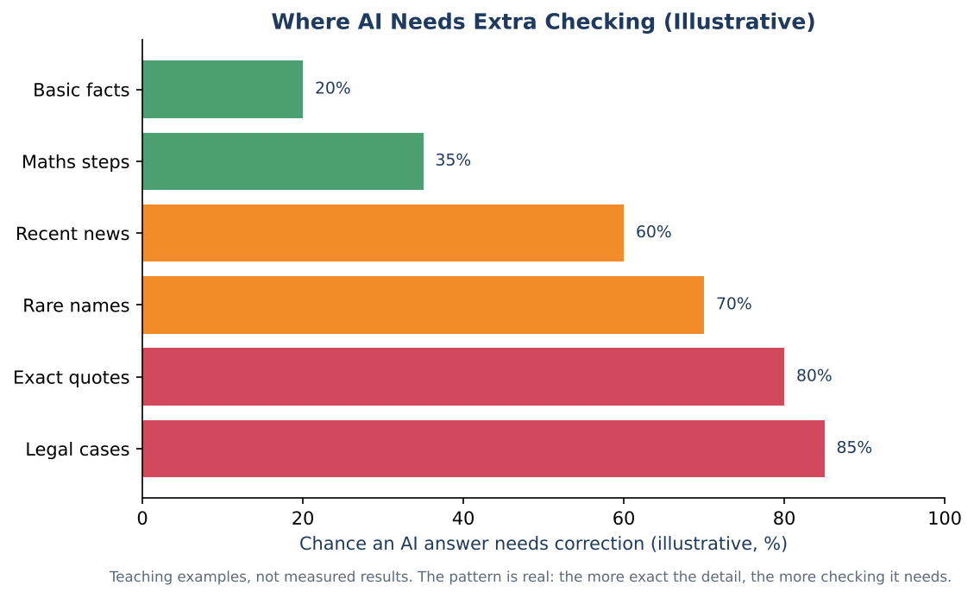
Figure 7.2: The more exact and unusual the detail, the more checking it needs (illustrative values).
Figure 7.2 gives a feeling of where mistakes are more likely. Simple, widely known facts and basic explanations are usually safer. Exact quotes, rare names, recent events and legal details need much more checking. The numbers in the chart are examples for learning, not measured results. The pattern, however, matches what researchers and teachers commonly observe.
KEY IDEA
A useful rule: the more specific, rare, recent or important a detail is, the more you must verify it.

SECTION 8

Two Kinds of Mistakes: False Alarms and Missed Cases
When AI makes a yes-or-no decision (fraud or not fraud, disease or healthy, spam or not spam), it can be wrong in two different ways. These two kinds of mistakes have different costs, and humans must decide which one matters more.

8.1 The four possible outcomes
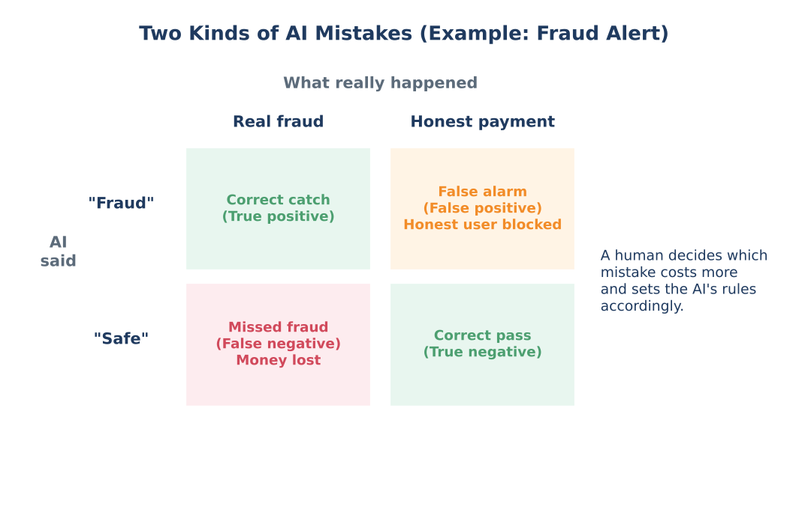
Figure 8.1: Four outcomes of a yes-or-no AI decision.
Study Figure 8.1 with the fraud alert example.
- True positive: the AI says "fraud" and it really is fraud. Good catch.
- True negative: the AI says "safe" and it really is safe. Good pass.
- False positive: the AI says "fraud" but the payment was honest. This is a false alarm. An honest customer is blocked.
- False negative: the AI says "safe" but it was fraud. This is a missed case. Money is lost.

8.2 Which mistake is worse?
It depends on the situation. Humans must think about the cost of each mistake and choose settings accordingly.
Situation | False alarm means | Missed case means | Usually worse
Disease screening | A healthy person is told to take more tests. | A sick person is told they are fine. | Missed case
Spam filter | An important email goes to the spam folder. | One spam email reaches the inbox. | Depends: missing a job offer can be worse
Exam cheating detector | An honest student is accused. | A cheating student is not caught. | False alarm (harming an innocent student is serious)
Airport security | A harmless bag is checked again. | A dangerous item passes. | Missed case
Plagiarism checker | Properly quoted text is marked as copied. | Copied text is not detected. | Both matter: a human must review

8.3 Why "99% accurate" can be misleading
Many people think that a high accuracy number means a system is excellent. Let us test this idea with a thought experiment.
EXAMPLE: The lazy disease detector
Suppose 1 in 100 people in a village has a certain disease. Someone builds an AI that simply says "healthy" for everyone. Out of 100 people, it is right for 99 and wrong for 1. Its accuracy is 99%. Yet it has caught zero sick people. It is useless as a disease detector.

The lesson is that a single accuracy number can hide serious problems. When someone says, "Our AI is 95% accurate," a careful person asks:
- Accurate on what kind of cases? (easy ones or hard ones?)
- Accurate for which groups of people?
- How many false alarms and how many missed cases are there?
- Who tested it, and when? Was the test done on realistic data?
- What happens to a person when the AI is wrong? Can the decision be reviewed?
THINK ABOUT IT: Your decision
A school wants an AI tool to alert teachers when a student may be in distress. If you were in charge, would you choose a setting that gives more false alarms or more missed cases? Who should check the alerts? Explain your reasoning.

KEY IDEA
The choice of how to balance false alarms and missed cases is a human decision about values. The AI cannot choose it for us. This is another reason why we must understand the humans behind AI decisions.

SECTION 9

The V-E-R-I-F-Y Method
Now we come to the practical heart of the chapter. Checking an AI answer is easier when you have a clear method. This chapter uses a six-step method called V-E-R-I-F-Y. Each letter stands for a step. The word itself reminds you of the goal.
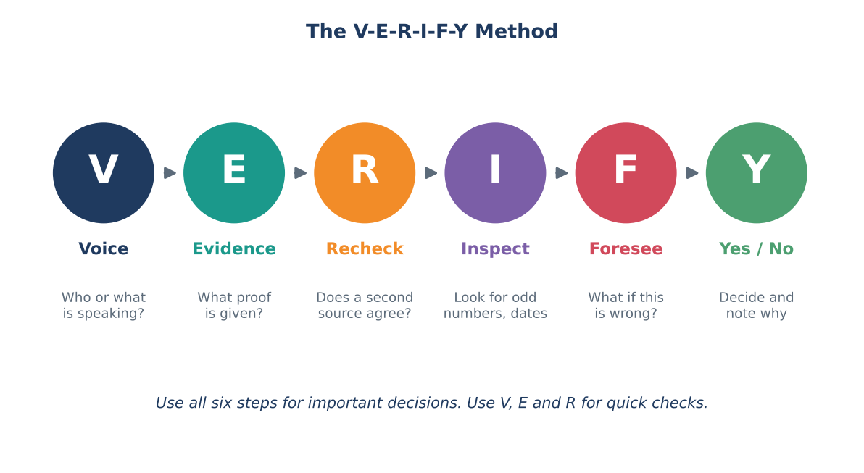
Figure 9.1: The six steps of the V-E-R-I-F-Y method.
Letter | Step | Key question
V | Voice | Who or what is speaking? Where does this answer come from?
E | Evidence | What proof, source or reasoning supports it?
R | Recheck | Does a second, independent source agree?
I | Inspect | Do the numbers, dates, names and logic hold up?
F | Foresee | What could go wrong if this is wrong? Who could be affected?
Y | Yes / No | Accept, change, reject or ask an expert. Record the decision.

9.1 V for Voice: who or what is speaking?
Every piece of information has a "voice": a source behind it. The first step is to identify the voice. With AI answers, the voice is not a single person. It is a tool built by a company, trained on certain data, with certain limits.
Ask these questions:
- Which tool produced this? Is it a general chatbot, a specialised tool (for example, for medicine or law) or a search engine?
- Is the tool connected to live information, or does it only use older training data?
- Did the tool show where its facts came from?
- Who made the tool, and what is its purpose? (An advertising company's AI may have different goals from a school's AI.)
- Am I reading the AI's own words, or something copied from a website that the AI summarised?
EXAMPLE: Voice check for Meera's note
Voice: a general chatbot. It did not name specific documents. It cannot confirm if its information is current. So the answer is a starting point, not a source.

9.2 E for Evidence: what supports the answer?
A claim is something stated as true. Evidence is something that supports the claim: a document, data, a study, an official record, a clear logical reason. A good habit is to separate the two. When you read an AI answer, underline each claim and ask, "Where is the evidence?"
Type of evidence | Example | Strength
Official record or original data | A government statistical release; an exam board notification. | Very strong
Peer-reviewed or expert study | A research paper in a recognised journal. | Strong
Trusted report | A report by a well-known news organisation with named sources. | Good, but check details
Expert opinion | A teacher, doctor or engineer explaining their field. | Good, if relevant
Anonymous or unclear claim | A forwarded message; a post without source. | Weak
"The AI said so" | An answer with no source. | Not evidence by itself

You can ask the AI to help with this step: "For each fact, list the source name, the year and where I can check it." But remember the lesson of Section 7: the sources it lists must also be checked. Treat the list as search clues, not proof.

9.3 R for Recheck: find a second, independent source
A single source can be wrong. A second source that agrees makes the claim stronger, but only if the two sources are independent. If two websites both copied the same wrong statement from the same place, their agreement means nothing.
KEY IDEA: The two-source rule
For anything important, find two independent, reliable sources that agree. If they disagree, find a third or ask an expert. If you can find only the AI as the source, treat the claim as unverified.

Independence means the sources have separate origins. Examples of independence: an official report and an independent newspaper investigation of the same event; a textbook and a government website. Examples of non-independence: two articles quoting the same press release; ten websites copying one another.

9.4 I for Inspect: look closely at the details
Many errors hide in details. Inspection means reading slowly and testing the small parts. Here is a checklist you can use:
Check | What to do | Example
Numbers | Recalculate; check units and decimal points. | Is it 1.5 lakh or 15 lakh? Is it per year or per month?
Dates and order | Check years and the order of events. | A law cannot be cited in a year before it was passed.
Names | Check spelling and titles of people, places, organisations. | Is it the same person or two people with similar names?
Logic | Does each step follow from the previous? | If A causes B and B causes C, does the answer wrongly say A equals C?
Consistency | Does the answer contradict itself? | Paragraph 1 says increased, paragraph 3 says decreased.
Reasonableness | Does the size or claim make sense? | A school lunch costing 5,000 rupees per child is clearly odd.
Links and references | Open each link; search each title. | Does the page really contain the statement?

TRY THIS: Sanity check practice
An AI answer says: "The average Indian student walks 40 kilometres to school every day." Without any research, explain in two sentences why this is almost certainly wrong. This is called a sanity check: using common sense to catch impossible claims.

9.5 F for Foresee: what if it is wrong?
The fifth step looks forward. Before you accept or act on an answer, imagine it is wrong and ask: what would happen? This step decides how much checking is needed.
- Impact: Would a mistake cause embarrassment, lost marks, lost money, health risk or harm to someone?
- Who is affected: only me, or also other people who rely on my work?
- Reversibility: Can I fix the mistake easily (a typo in a note) or is it permanent (a message sent to hundreds of people, a medicine taken, a form submitted)?
- Time: Is there time to check now? If not, is it better to wait?
If the foreseen result is serious, return to steps R and I and check more deeply, or ask a qualified human (a teacher, doctor, lawyer, counsellor, bank officer).

9.6 Y for Yes / No: decide and record
The last step is a decision. After checking, you have four options:
Decision | When to choose it
Accept | Evidence is strong and checks match.
Accept with changes | Most of the answer is right but some parts are corrected.
Reject | Evidence is missing or the answer is contradicted by reliable sources.
Ask an expert | The stakes are high or you cannot settle the question yourself.

Then record your decision briefly: what you checked, which sources you used and the date. Writing this down takes one minute but builds good habits and gives you proof of your work. It is also the way professionals work.

9.7 A complete worked example
STORY: Checking an AI answer about a scholarship
Ravi asks an AI tool: "What is the last date to apply for the national scholarship exam this year, and what is the eligibility?" The AI replies with a specific date and says that students with family income below a certain amount can apply.

Step | What Ravi did | Result
V - Voice | Noticed the tool is a general chatbot, and it did not say whether it can see current notices. | Treat as unverified. Dates change every year.
E - Evidence | Asked: "Which official notice says this? Give the name of the issuing body." The AI named the issuing body but gave no notice number. | Evidence incomplete.
R - Recheck | Visited the official website of the issuing body and opened the current notification. Asked his teacher to confirm. | Official notice shows a different last date.
I - Inspect | Compared eligibility lines. The income limit in the AI answer was from an earlier year. | AI answer partly outdated.
F - Foresee | If he trusted the AI date, he might miss the deadline and lose a year. | High stakes.
Y - Yes/No | Rejected the AI date, used the official date and noted the source and the day he checked. | Application submitted on time.

KEY IDEA
The AI helped Ravi know what to look for. The official source told him what was true. This is the best way to use AI: as a guide that points to the evidence, not as the final authority.

9.8 The 3-minute quick check
You cannot spend an hour on every answer. For small or medium tasks, use this short version of the method:
- Underline the facts (numbers, names, dates, claims).
- Pick the top three that matter most or look strangest.
- Search each one in a reliable source. Open the source, do not just read a snippet.
- Fix or remove anything you cannot confirm.
- Add a note such as "Checked with [source] on [date]".

9.9 Red flags checklist
These warning signs mean you should slow down and verify more:
- The answer contains very exact numbers or quotes without a source.
- It uses emotional or urgent language: "Share immediately!", "Last chance!"
- It claims something amazing or shocking that you have not seen anywhere else.
- It agrees with everything you said, with no disagreement at all.
- A link does not open, or the page does not contain the claim.
- The AI changes its answer when you ask the same question again.
- It gives advice about health, money, law or safety that sounds absolute.
- It asks for personal information, passwords or OTPs.

SECTION 10

Sources, Lateral Reading and Fact-Checking
Verification depends on finding good sources. This section teaches how to judge a source, how to compare sources quickly and which tools can help.

10.1 The source reliability ladder
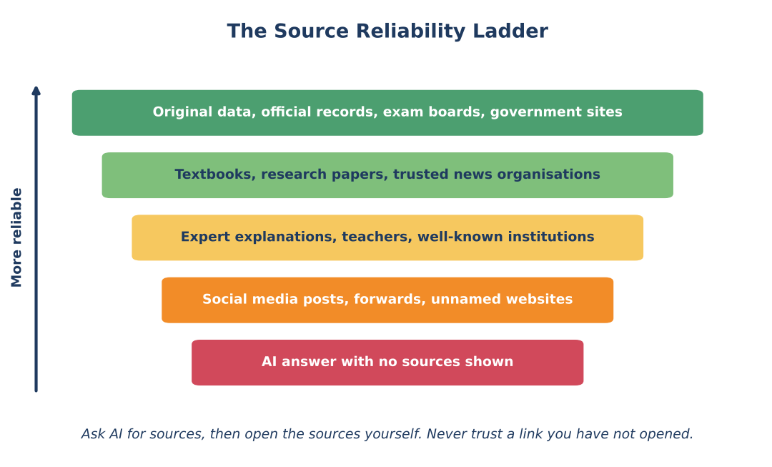
Figure 10.1: Some sources are generally more reliable than others.
The ladder gives a general guide, not a rigid rule. At the top are original data and official records: for example, an exam board's notification, a government statistics release, a hospital's own published guidelines, a company's annual report. These are closest to the facts. Next come textbooks, research papers and trusted news organisations which usually have editors and checking processes. Then come expert explanations from teachers, doctors, engineers and institutions. Lower down are social media posts, forwarded messages and unnamed websites, which can be useful for finding leads but are weak as proof. At the bottom is an AI answer with no sources shown: a useful starting point, but unverified.
BE CAREFUL: Even good sources can be wrong
No ladder is perfect. Official sources can have typing errors or may be updated later. Experts may disagree. Always look at the date, and when stakes are high, ask for a second confirmation.

10.2 Four questions to judge any source
Question | What to look for
Who made it? | A named person or organisation with real knowledge in this area. Anonymous or unclear authorship is a warning.
When was it made? | A clear date and recent enough for the topic. Old pages may carry old rules.
Why was it made? | To inform, to sell, to persuade, to entertain? Purpose affects what is included.
How do they know? | Do they show data, documents or sources you can check, or only opinions?

10.3 Lateral reading: the fact-checker's trick
Professional fact-checkers do something that beginners often do not. When they meet an unknown source or claim, they do not keep reading it deeply. Instead, they leave the page and open new tabs to see what other sources say about it. This is called lateral reading. The old way, reading down the same page again and again, is called vertical reading.
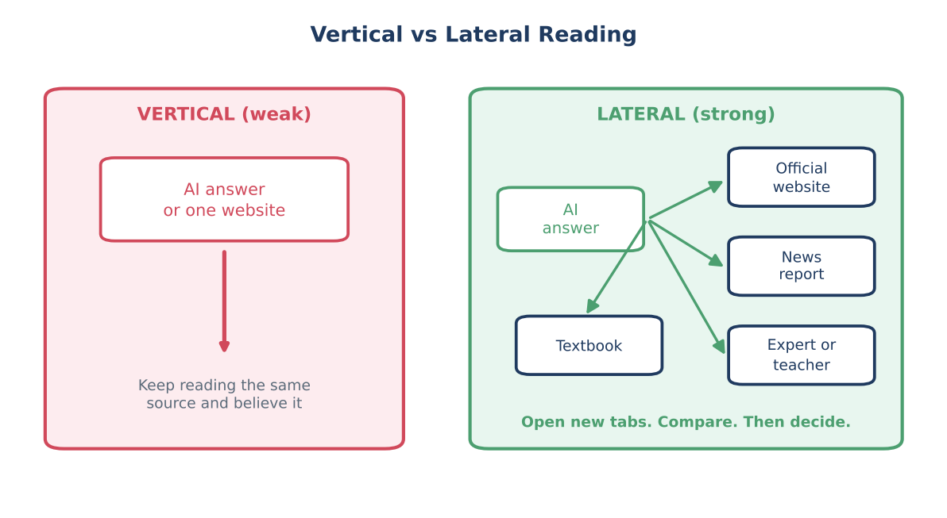
Figure 10.2: Lateral reading means checking sideways across several sources.
Why does lateral reading work? A page can be designed to look reliable: neat layout, serious language, official-looking logos. Reading more on that page will not reveal whether it is trustworthy, because the page is controlling the story. But if you search for the claim or the website in other places, you quickly learn what others say. Fact-checkers can often decide in under a minute.
TRY THIS: Lateral reading in four moves
1. Copy the main claim (or the name of the website).
2. Open a new tab and search it.
3. Look at who else reports it: official sites, major news organisations, fact-checkers.
4. Return to the first source with a better idea of whether to trust it.

10.4 Useful tools and habits
Tool or habit | What it helps with
Official websites (for example government portals ending in .gov.in or .nic.in, exam boards, RBI, NCERT, CBSE) | Original rules, notices, data, dates. Type the address yourself or use a trusted bookmark. Do not trust links in unknown messages.
Search with the exact claim in quotation marks | Shows whether anybody else reports the same statement, and where.
Reverse image search (for example Google Lens, TinEye) | Finds the earlier appearance of a picture and shows whether it is old or used out of context.
Fact-checking organisations and government fact-check units | Often already checked viral claims.
Library catalogues and scholarly databases | Confirm that a book or paper exists.
Calculators and spreadsheets | Check numbers and calculations independently.
Run the code | If AI writes code, run and test it; never assume it works.

BE CAREFUL: Look-alike websites
Scammers create websites with names very close to real ones, for example an extra letter or a different ending. A padlock symbol in the browser means the connection is encrypted; it does not prove the site is honest. Check the exact address carefully before entering any personal or payment details.

10.5 Verifying different kinds of AI output
AI output | Best way to verify
Facts and statistics | Find the original data source and compare; check the year and the unit.
Summaries of a document | Read the original, at least the key parts; check that nothing important was changed or left out.
Mathematics and science explanations | Recalculate; compare with a textbook; test with a simple example.
Programming code | Run it, test different inputs, read it line by line, check for security issues.
Quotes | Search for the quotation and the original text; AI-made quotes are often wrong.
Translations | Ask a fluent speaker or compare with a second translation tool for important texts.
Health, legal, financial advice | Use as general information only. Confirm with a qualified professional.
Images, audio, video | Trace the source; reverse search; look for visual or audio errors; check trusted news.

SECTION 11

How Much Should You Verify?
If we verified everything to the maximum, we would never finish any work. If we verified nothing, we would make serious mistakes. The skill is matching the amount of checking to the amount of risk.

11.1 The stakes matrix
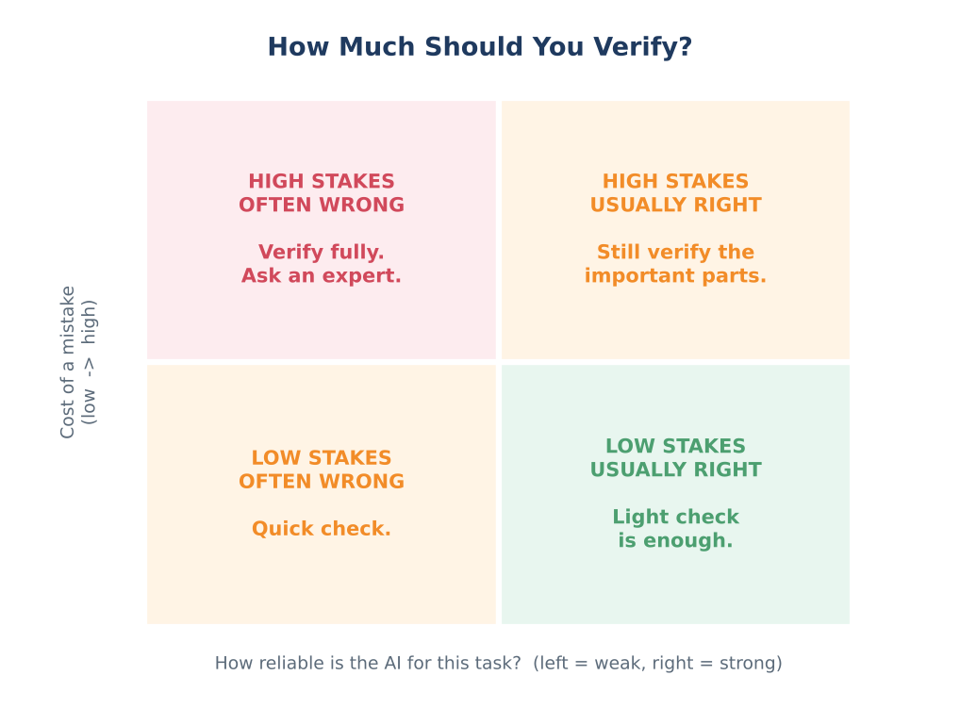
Figure 11.1: Decide how much to check by combining the cost of a mistake with how reliable the AI is for the task.
Two questions help you decide: How costly is a mistake? and How reliable is the AI for this kind of task?
- High stakes and AI often wrong (top left): verify fully and consult an expert. Example: medical dosage for a family member.
- High stakes and AI usually right (top right): even if the tool is usually good, check the key parts. Example: final dates for an application.
- Low stakes and AI often wrong (bottom left): quick check is enough. Example: a fun fact for a class quiz.
- Low stakes and AI usually right (bottom right): a light check is enough. Example: improving the grammar of your own paragraph.

11.2 Four levels of checking
Level | Name | What you do | Example tasks
1 | Glance | Read once and see if anything looks odd. | Brainstorm ideas for a poster title.
2 | Quick check | 3-minute check of the top facts. | A school note, a class presentation.
3 | Full check | Full V-E-R-I-F-Y with two sources. | A project report, an application form, a competition entry.
4 | Expert check | Full check plus a qualified person reviews it. | Health, legal, money and safety decisions.

11.3 How much control should a human keep?
The same question applies to systems that make decisions for many people. Designers and organisations must decide how closely humans stay involved. There are three common patterns.
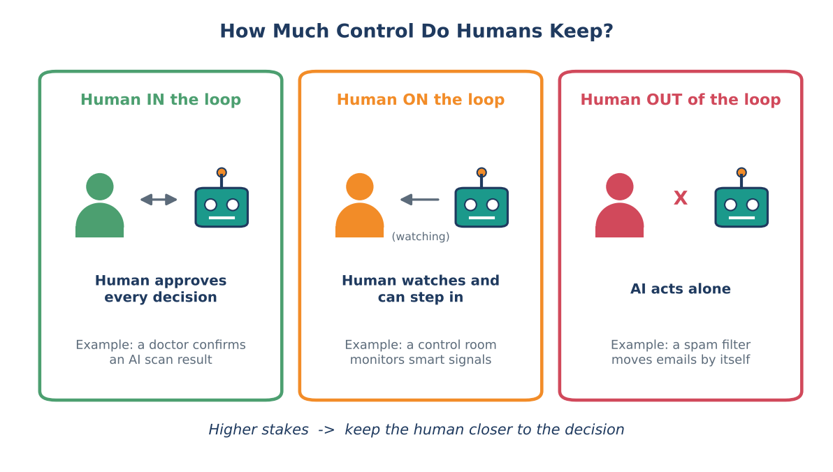
Figure 11.2: Three ways humans can stay involved with an AI system.
- Human in the loop: the AI suggests, and a human approves every decision. This suits high-stakes tasks such as medical diagnosis, hiring decisions or exam results.
- Human on the loop: the AI acts by itself but a human watches and can step in. This suits systems with many small decisions that must be quick, such as traffic management, with humans supervising.
- Human out of the loop: the AI acts alone. This is acceptable only when mistakes are minor and easy to fix, such as sorting spam email, and even then people should be able to recover wrongly filtered messages.
KEY IDEA: A simple rule
The higher the stakes for people, the closer the human should be to the decision. Never let AI be the only decision-maker for matters that affect health, safety, rights, education results or livelihood.

THINK ABOUT IT: Which pattern fits?
For each system choose: in the loop, on the loop, or out of the loop. Explain your choice. (a) Approving a student's scholarship. (b) Choosing the next song in a music app. (c) Deciding whether a patient needs urgent surgery. (d) Adjusting classroom lights by sunlight.

SECTION 12

Responsibility, Ethics and You

12.1 A chain of responsibility
When AI makes a mistake, who is responsible? Sometimes people say, "It is the AI's fault." But AI cannot take responsibility: it cannot apologise, pay compensation or promise to improve. Responsibility lies with humans and organisations. In fact, it is shared along a chain.
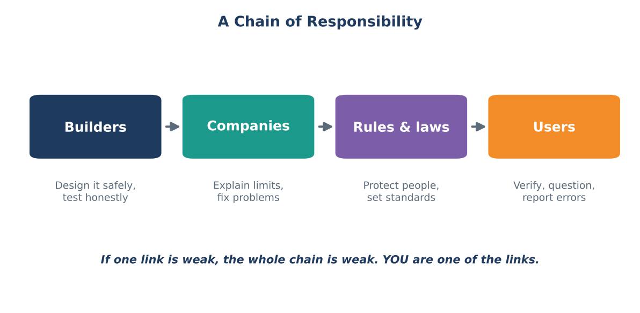
Figure 12.1: Responsibility is shared. Every link matters.
Link in the chain | Main responsibilities
Builders (engineers, researchers) | Design carefully, test honestly on different groups, report known limits, fix problems.
Companies and organisations that deploy AI | Decide where AI is used, explain it clearly, provide human review and complaint routes, take responsibility for the information their tools give.
Rules and laws (regulators, courts) | Set standards for safety, fairness and privacy; protect people; decide consequences.
Users (you) | Use tools wisely, verify before trusting, protect privacy, give honest credit, report errors, avoid harm to others.

EXAMPLE: A chatbot and an airline
In 2024, a Canadian tribunal decided a case involving an airline's website chatbot. The chatbot had given a customer wrong information about discounted fares after a family death. The airline argued that the chatbot was a separate source responsible for its own words. The tribunal did not accept this and held the airline responsible for the information on its own website, including its chatbot. The lesson: organisations cannot hide behind their AI tools.

12.2 Key principles of responsible AI
Principle | Plain meaning | Question to ask
Fairness | Treat people equally; avoid unfair harm to groups. | Does it work equally well for everyone?
Transparency | Be open about what the AI is and how it is used. | Do I know that AI is involved? Do I know its limits?
Explainability | Be able to give reasons for a decision. | Can someone explain why this decision was made?
Accountability | Someone is responsible and can fix problems. | Who do I contact if it is wrong?
Privacy | Protect personal information. | What data is collected and why?
Safety and security | Avoid harm; protect against misuse. | What is the worst that could happen, and how is it prevented?
Human oversight | Humans can review, override or stop the AI. | Can a human change this decision?

12.3 Your own responsibility as an AI user

Protect privacy
Many AI tools store what you type. Do not put in passwords, OTPs, bank details, ID numbers, private photos or other people's personal information. In India, the Digital Personal Data Protection Act, 2023 was passed to protect personal data, but your best protection is to share less. Read the privacy settings of the tools you use. Ask a parent or teacher if you are unsure.

Be honest about AI use
If you use AI for an assignment, follow your school's rules. Say how you used it: for ideas, for checking grammar, for explanation. Never present AI work as completely your own when rules say otherwise. Remember also that copying without understanding is a loss for you: the exam hall will not allow AI.

Respect others
Do not use AI to create fake pictures, voices or messages that harm, shame or trick other people. Creating or sharing deepfakes of classmates, teachers or family can cause serious harm and may be a legal offence. If you see such content, do not forward it; report it to a trusted adult or the platform.

Report problems
If an AI tool gives dangerous, false or unfair output, use the feedback or report option. Your report can help the humans behind the tool to fix it. This is a practical way of taking part in the chain of responsibility.

12.4 Careers: people who guide AI
Because humans are behind AI, many careers are about guiding, checking and improving it. Some examples are listed below. Notice that many of them need not only technology skills but also clear thinking, language and ethics.
Career | What the person does
Data analyst / data scientist | Prepares data, builds and tests models, explains results.
Machine learning engineer | Builds and improves AI systems.
AI quality and safety tester | Tests AI for errors, bias and misuse before release.
Data labeler / annotation specialist | Tags examples that train AI.
AI policy and ethics specialist | Helps create rules and guidelines for fair and safe AI.
Domain expert (doctor, teacher, lawyer, engineer) | Checks AI results using real-world knowledge.
Fact-checker and trust-and-safety analyst | Finds misinformation and harmful content.

KEY IDEA
The future of AI is not "machines instead of people". It is people who can work with machines wisely. Your ability to verify, question and decide is what makes you valuable.

SECTION 13

Verify in Prompt - Plan - Produce
Your course is built around three working steps: Prompt, Plan, Produce. So far, you have learned about verification as a separate skill. In real work, verification must be woven into the workflow. Figure 13.1 shows how.
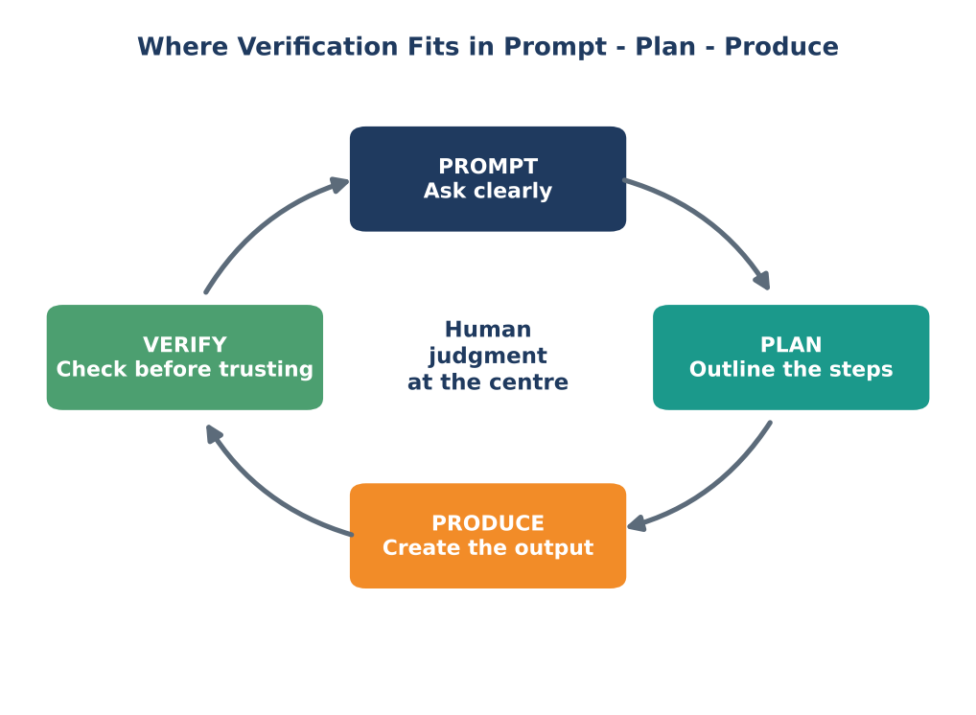
Figure 13.1: Verification closes the loop. Human judgment sits at the centre.
Notice two things in the picture. First, Verify is a step in the cycle, not an optional extra. Second, human judgment is in the middle: at each step, a human decides what to ask, how to organise, what to accept and what to correct. This is the human behind AI decisions, and now that human is you.

13.1 Prompt: ask in a way that makes checking easier
A good prompt does not only ask for an answer. It prepares the answer for verification. You can include requests such as:
- "Give the source name and year for each fact."
- "Separate what you are sure of from what you are not sure of."
- "If you do not know, say you do not know. Do not guess."
- "Show your steps so I can check them."
- "Give me both sides of the argument."
- "What would an expert in this field disagree with in your answer?"
Goal | Prompt pattern you can use
Get checkable facts | "List five facts about [topic]. For each, give the source (organisation, document name, year) so I can verify it."
Reduce guessing | "Answer only if you are confident. If you are not sure, tell me exactly which part is uncertain."
Check maths | "Solve step by step and show each calculation. Then check your answer a second way."
Find weak points | "Now act as a critical reviewer and list the three most likely errors in your answer."
Balanced view | "Give the strongest arguments for and against [position], with sources."
Plain language | "Explain this for a Class 12 student in simple English, then give me a list of key terms to look up."
Latest information | "Is this information current? Tell me how to confirm the latest version on an official website."
Summarise safely | "Summarise the text I pasted. Only use the text. Do not add outside information."

BE CAREFUL: A prompt does not guarantee truth
Even a perfect prompt cannot make a wrong answer right. Asking for sources may produce fake sources. The prompt makes checking easier; it does not replace checking.

13.2 Plan: build verification into your plan
When you plan your task, add verification as a visible step, with time set aside. A common mistake is to plan three hours for writing and no time for checking. A better rule of thumb for work that matters: leave about one quarter of your time for verification and correction.
EXAMPLE: Plan for a presentation on renewable energy in India
Task: a 10-slide presentation. Time available: 4 hours.

Step | Task | Use of AI | Verification step | Time
1 | Decide the main message and audience | Brainstorm outline | Teacher approves outline | 20 min
2 | Collect facts and figures | Suggest topics and where to look | Take every number from an official source | 60 min
3 | Draft slide text | Help with wording | Compare each slide with sources | 60 min
4 | Create visuals | Suggest chart ideas | Draw charts from verified numbers only | 40 min
5 | Final verification | Ask AI to find possible errors | Run V-E-R-I-F-Y on all numbers and claims | 40 min
6 | Practice and credits | Suggest practice questions | List sources; note where AI helped | 20 min

13.3 Produce: label and keep track
When you produce the final output (a note, a presentation, a report, a piece of code), follow these good habits:
- Mark unverified items while drafting (for example with a highlight) and clear the highlight only when verified.
- Keep the sources next to the facts: a reference list or notes.
- Keep the original AI draft and your corrected version, so you can see what changed.
- State AI use where required: "Draft ideas generated with an AI tool; all facts verified by the author."
- Take ownership. When your name is on the work, you are responsible for every sentence.

13.4 Verify and improve: the loop
After verification, you may discover errors. Then you return to Prompt: "The figure for 2022 you gave does not match the official source. Here is the official figure. Please rewrite this paragraph using it." This feedback loop is how humans and AI can work well together: AI offers speed, humans offer judgment.

13.5 The Verification Log
A Verification Log is a simple table where you record what you checked. Keep one for a month. You will be surprised how often AI answers need corrections, and how quickly you become faster at checking.
Date | Task / question | AI claim checked | Source used to check | Result (correct / changed / rejected) | Time
12 Oct | Inflation note | Inflation figure for last year | Official statistics release | Changed: wrong year | 6 min

SECTION 14

Case Studies and Activities
This section gives you four short case studies and eight activities. The case studies are fictional but realistic. Work in small groups, discuss, and apply the ideas from this chapter.

14.1 Case studies
STORY: Case Study 1: The Loan App
A mobile loan app uses AI to decide in seconds whether to give a small loan to a college student. It looks at the student's phone model, location, shopping history and contacts. Priya, a hard-working student from a small town, is refused. The app gives no reason. A classmate with a more expensive phone and the same family income gets the loan.

- Which human decisions might be behind this result (goal, data, labels, threshold)?
- Could any of the data act as a proxy for something unfair? Which?
- Which kind of mistake did the AI make with Priya: a false alarm or a missed case?
- What rights or options should Priya have? Who should be responsible for explaining the decision?
- Apply V-E-R-I-F-Y: what would you want to verify before trusting the app's decision?
STORY: Case Study 2: The Health Tips Chatbot
Karthik has a stomach ache for three days. He asks an AI chatbot, "What should I take?" The chatbot lists a medicine name and a dose and says it is safe. Karthik's friend says, "AI is smart, just take it." Karthik is not sure.

- Which level of checking (1 to 4) is needed here? Why?
- What are three possible errors in the chatbot's answer (think about outdated advice, missing context, wrong dose)?
- Who is the best human to verify this advice?
- Write one safer prompt Karthik could have used, and one thing he should do even after getting a good answer.
STORY: Case Study 3: The Viral Video
A video spreads on messaging apps. It shows a well-known sports player announcing a surprising decision to leave the country. The voice sounds exactly like the player. Messages say "Forward to 10 people!" Within an hour, thousands of people are arguing online.

- List five red flags in the situation.
- Describe the steps of lateral reading you would follow.
- What might be the purpose behind creating and spreading such a video?
- What should you do before forwarding it, and what could happen if you forward it without checking?
STORY: Case Study 4: The Attendance Predictor
A school uses AI to predict which students are likely to be absent often. The AI was trained on the last three years' data. It flags many students from one hostel. Teachers start calling those students' parents without further checking. Later, the school discovers that the hostel's bus was repeatedly late in those years, which caused many of the absences.

- What went wrong in terms of data, goal and use? Which stage of the pipeline (Figure 4.2) needs improvement?
- Which pattern would be better: human in, on or out of the loop? Why?
- Suggest two changes that would make the system fairer and more useful.

14.2 Activities

Activity 1: Map the humans behind an AI tool
- Choose a tool you use often (a video feed, a map app, a chatbot, a shopping app).
- Draw the six-stage pipeline.
- Write at least one human decision for each stage.
- Share with a partner and add anything they noticed that you missed.

Activity 2: Hallucination hunt
- Ask an AI tool three questions about topics you know very well (your village, your hobby, your favourite sport).
- Check each answer carefully and mark every mistake you find.
- Count how many mistakes appeared per answer. Which kind of question produced the most mistakes?
- Write a short note: what did you learn about trusting AI on topics you do not know well?

Activity 3: The two-source challenge
- Take five facts from an AI answer.
- For each fact, find two independent reliable sources.
- Fill the table below. If you cannot find two sources, mark the fact as unverified.
Fact | Source 1 (name, date) | Source 2 (name, date) | Independent? (yes / no) | Verdict

Activity 4: Compare the answers
Ask the same AI tool to describe "a successful engineer", "a successful nurse", "a successful farmer" and "a successful pilot". Compare the descriptions. Do they use different images of people? Do they make assumptions about gender, age or background? Discuss whether you see any bias and what could be the cause.

Activity 5: Picture detective
- Your teacher gives you three pictures: one real, one edited and one AI-made (or you find your own examples with permission).
- For each picture, write where you think it came from and how confident you are.
- Use reverse image search to find the earliest version.
- Look for small clues (hands, text, shadows, reflections). Discuss what you found.

Activity 6: The threshold game (class simulation)
Your teacher prepares 20 cards. Each card shows a made-up "risk score" from 0 to 100, and on the back, a secret label: "fraud" or "honest". Four cards are fraud, sixteen are honest.
- Choose a threshold (for example, 60). Place all cards with a score above it in the "blocked" pile.
- Turn over the blocked cards. Count how many were fraud and how many were honest.
- Count the fraud cards left in the "allowed" pile.
- Change the threshold and repeat. Record the results in a table.
- Discuss: which threshold would you choose, and why? Who is affected by your choice?

Activity 7: Class debate
Motion: "AI should make the final decision on school and college admissions." Divide the class into two teams. Use ideas from this chapter: speed and consistency (for), bias, explainability, accountability and human oversight (against). After the debate, each student writes a short paragraph giving their own view and one condition under which they would accept AI help in admissions.

Activity 8: One-month Verification Log
For one month, record at least one AI answer per week that you verified. Use the log format in Section 13.5. At the end of the month, answer: How many answers needed changes? Which types of errors were most common? Did your checking get faster?

14.3 Worksheet A: V-E-R-I-F-Y checking sheet
Photocopy or re-create this sheet for any AI answer you want to check.
Step | My notes
V - Voice: Which tool? Does it show sources? Is information current?
E - Evidence: What proof is given? What sources can I find?
R - Recheck: Which two independent sources did I use?
I - Inspect: What numbers, dates, names, logic did I check?
F - Foresee: What happens if this is wrong? Who is affected?
Y - Yes/No: My decision (accept / change / reject / ask expert) and the date.

14.4 Worksheet B: Source rating sheet
Source name / link | Who made it? | When? | Why made? | How do they know? | Ladder level (1 to 5)

14.5 Worksheet C: Questions I want to ask the humans behind this AI
Choose an AI tool or system. Write five questions that you would like its builders or owners to answer. Examples: What data did you use? Who is missing from it? How did you test it? What do you do when it makes a mistake? How can I ask for a human review?

SECTION 15

Summary, Glossary and Assessment

15.1 Chapter summary
- Verify Before You Trust means checking AI answers with evidence before accepting or sharing them. The aim is calibrated trust, not blind trust and not total distrust.
- AI systems learn patterns from data and make predictions. They produce likely answers, not guaranteed truths.
- Humans are behind every AI decision: data collectors, labelers, engineers, managers, regulators and users. Human choices at every stage shape what the AI does.
- Choices about goals, data, labels, thresholds, rules, testing and use can all create or prevent problems.
- AI can be biased when data is unbalanced, labels are subjective, proxies are used or feedback loops form. Humans must test, audit and correct it.
- Common AI errors include hallucination, outdated information, overconfidence, context mistakes, calculation slips, fake sources and synthetic media.
- AI decisions can fail in two ways: false alarms and missed cases. Humans must decide which is more costly. A high accuracy number can hide serious problems.
- Use the V-E-R-I-F-Y method: Voice, Evidence, Recheck, Inspect, Foresee, Yes/No.
- Use lateral reading and the source reliability ladder to judge sources. Prefer original and official sources.
- Match checking to stakes. For high-stakes decisions keep a human in the loop and ask an expert.
- Responsibility is shared along a chain: builders, organisations, rules and users. AI cannot be blamed instead of people.
- Build verification into Prompt - Plan - Produce, keep a verification log and be honest about AI use.

15.2 Key terms
Term | Meaning
Accuracy | The share of AI answers that are correct. It can hide problems if cases are unbalanced.
Accountability | Being answerable for decisions and fixing the problems they cause.
Algorithm | A set of step-by-step instructions that a computer follows.
Artificial intelligence (AI) | Computer systems that perform tasks that normally need human intelligence, such as understanding language or recognising pictures.
Bias | A systematic unfair tilt in results for some people or situations.
Calibrated trust | Trust adjusted to match the strength of the evidence.
Deepfake | Realistic fake image, audio or video made with AI.
Explainability | The ability to give understandable reasons for an AI decision.
False negative | A missed case: the AI says no when the real answer is yes.
False positive | A false alarm: the AI says yes when the real answer is no.
Feedback loop | A cycle in which results of a system become new input and strengthen the same pattern.
Hallucination | False or made-up AI output presented as true.
Human in the loop | A design in which a human approves or reviews each important AI decision.
Independent source | A source with a separate origin from another source.
Label | A tag that tells the AI what an example is (for example "spam").
Large language model | An AI trained on huge amounts of text to generate language.
Lateral reading | Checking a source by opening other sources to see what they say about it.
Machine learning | A type of AI that learns patterns from data.
Prediction | The AI's best guess about a new case based on learned patterns.
Prompt | The instruction or question you give to an AI tool.
Proxy data | Data that indirectly stands in for something sensitive.
Sycophancy | The tendency of an AI to agree with or please the user instead of correcting them.
Threshold | The cut-off score that decides when an AI result triggers an action.
Training cutoff | The date after which an AI has no built-in knowledge.
Training data | The examples used to teach an AI.
Transparency | Being open about when and how AI is used.
Verification | Checking something against evidence to see whether it is true or reliable.

15.3 Assessment

Part A: Multiple choice (1 mark each)
Choose the best answer.
- "Verify Before You Trust" means: (A) never use AI; (B) check AI results with evidence before accepting them; (C) trust AI only if it sounds confident; (D) ask a friend if AI is right.
- Calibrated trust is: (A) trusting everything; (B) trusting nothing; (C) trust that matches the strength of evidence; (D) trust only official websites.
- A large language model mainly produces answers by: (A) looking up a guaranteed fact each time; (B) predicting likely text from patterns learned in data; (C) asking human experts live; (D) copying the first search result.
- A hallucination in AI is: (A) a computer virus; (B) a fast answer; (C) a false or made-up output presented as true; (D) an answer in another language.
- In a fraud system, who decides the risk score above which payments are blocked? (A) the AI alone; (B) the customer; (C) people in the bank who set the rule; (D) nobody.
- The bias loop can be broken mainly by: (A) waiting; (B) human review and correction of data, rules or process; (C) giving the AI more power; (D) using a faster computer.
- Lateral reading means: (A) reading a page from top to bottom; (B) reading in a sideways book; (C) opening other sources to check what they say about a source or claim; (D) reading only headlines.
- Two sources are independent when: (A) they have the same author; (B) one copied the other; (C) they come from separate origins; (D) they are on the same website.
- In V-E-R-I-F-Y, the letter F stands for: (A) Finish; (B) Foresee; (C) Forward; (D) Facts.
- The lazy disease detector example shows that: (A) AI is always useless; (B) a high accuracy number can hide serious failure; (C) diseases are rare; (D) humans are not needed.
- A design where a human approves every AI decision is called: (A) human out of the loop; (B) human on the loop; (C) human in the loop; (D) human around the loop.
- An AI gives a legal case citation. The best first step is to: (A) copy it; (B) search for the case in an official or reliable legal database; (C) ask the AI again; (D) ignore the date.
- Which of these is generally the most reliable? (A) a forwarded message; (B) an AI answer with no source; (C) an official government notification; (D) an anonymous website.
- A false negative in a fraud detector means: (A) an honest payment is blocked; (B) a fraud payment is missed; (C) a fraud payment is caught; (D) an honest payment is allowed.
- When an AI tool makes a harmful mistake, responsibility: (A) lies only with the AI; (B) is shared among builders, organisations, rules and users; (C) lies only with the user; (D) lies with nobody.

Part B: True or false (1 mark each)
- A confident tone shows that an AI answer is correct.
- AI systems are built, trained and used by people, so human choices affect their results.
- If two websites say the same thing, they must be independent sources.
- A padlock in the web address proves the website is honest.
- Higher stakes mean you should check more carefully.
- AI can create fake voices and videos that look real.
- A single accuracy number tells the whole story about an AI system.
- It is wise to share OTPs and passwords with AI chat tools to get better help.
- Keeping a human in the loop matters most for decisions that affect health, safety and rights.
- Verification is a skill used by professionals, not a sign of weakness.

Part C: Short answers (3 marks each)
- Explain "Verify Before You Trust" in your own words with one example from your life.
- Name any four groups of people behind an AI decision and say what one of them does.
- What is the difference between a false positive and a false negative? Give one example.
- List three possible sources of bias in AI.
- What is lateral reading and why is it better than reading only one page?
- Explain why an AI answer with a source list still needs checking.
- State any three red flags that suggest an answer needs deeper verification.
- Describe how you would add verification to a Prompt - Plan - Produce task.

Part D: Long answers (6 marks each)
- Describe the six stages of building and using an AI system and give one human decision at each stage, using any example.
- Using a worked example, explain each step of the V-E-R-I-F-Y method.
- "The algorithm decided" is not a full explanation. Discuss this statement with examples of human choices behind AI decisions.
- Explain the stakes matrix and the four levels of checking. Give one example task for each level.

Part E: Mini project (10 marks): The AI Answer Audit
Choose five AI answers on topics related to your studies (for example a physics concept, a historical date, a statistic, a programming snippet, a health fact). For each answer, apply the V-E-R-I-F-Y method and record the result in a table. Then write a one-page reflection answering: How reliable were the answers? Which errors did you find? What did you learn about the humans behind the tool? Present your findings to the class in three minutes.
Criteria | Marks | What the teacher looks for
Variety and relevance of the five answers | 2 | Different kinds of claims; useful for the subject.
Correct use of V-E-R-I-F-Y | 3 | All six steps shown with evidence of real checking.
Quality of sources | 2 | Reliable, independent sources; links or references given.
Reflection | 2 | Honest, thoughtful insight about errors and human choices.
Presentation | 1 | Clear and within the time limit.

15.4 Answer key

Part A
Q | 1 | 2 | 3 | 4 | 5 | 6 | 7 | 8 | 9 | 10 | 11 | 12 | 13 | 14 | 15
Ans | B | C | B | C | C | B | C | C | B | B | C | B | C | B | B

Part B
Q | Answer | Reason
1 | False | Tone is not evidence of accuracy.
2 | True | People make choices at every stage.
3 | False | They may have copied one another.
4 | False | A padlock shows an encrypted connection only.
5 | True | Higher stakes need deeper checking.
6 | True | Deepfakes and synthetic media exist.
7 | False | Accuracy can hide unequal or serious errors.
8 | False | Never share OTPs or passwords.
9 | True | Human oversight protects people when stakes are high.
10 | True | Skilled people verify more, not less.

Parts C, D and E are marked by the teacher using the content of the relevant sections of this chapter.

15.5 Reflection
Write three to five sentences in answer to each question.
- After this chapter, what will you do differently the next time an AI tool gives you an answer?
- Which part of the human chain behind AI surprised you most, and why?
- How would you explain "Verify Before You Trust" to a younger sibling or a grandparent?

15.6 Suggested teaching plan
A teacher may use the following plan of about eight periods for this chapter.
Period | Sections | Focus | Activity
1 | 0, 1, 2 | Story and meaning of trust and verification | Discuss Meera's story; spot your habit
2 | 3 | How AI makes decisions | Pattern game with examples
3 | 4, 5 | Humans behind AI; human choices | Activity 1: map the humans; threshold example
4 | 6 | Bias | Activity 4: compare the answers
5 | 7, 8 | Errors and two kinds of mistakes | Activity 2: hallucination hunt; Activity 6: threshold game
6 | 9 | V-E-R-I-F-Y method | Worked example; Worksheet A
7 | 10, 11 | Sources, lateral reading, stakes | Activity 3 and Activity 5
8 | 12, 13, 14, 15 | Responsibility, workflow, assessment | Activity 7: debate; start Verification Log; mini project

KEY IDEA: Final thought
AI will keep improving, but one thing will not change: someone must stay responsible for the truth of what we say and do. That someone is a human being. Learn to ask good questions, check carefully and decide wisely. Verify before you trust.

